DSP Projects of Chapter 4

1. Download an audio signal file with a sampling rate of 16 KHz from the course Web site and process the signal as follows.

a. Change the sampling rate to 12 KHz for the audio signal.

我用python做了resample的function

Code:

import wave

from scipy.io import wavfile

import os

from scipy.interpolate import interp1d

import numpy as np

import matplotlib.pyplot as plt

import warnings

warnings.simplefilter("ignore", DeprecationWarning)

filepath = '/Users/abc/Desktop/NCKU/NE6101034_DSP_hw2/singing16k16bit-clean.wav'

fs, data = wavfile.read(filepath)

wav_time = len(data)/fs

pre_inter_x = np.linspace(1/fs, wav_time, len(data)) #單位 sec

pre_inter_y = data

print("Pre Resample Length: ", len(pre_inter_y))

plt.plot(pre_inter_x, pre_inter_y)

f = interp1d(pre_inter_x, pre_inter_y)

post_inter_x = np.linspace(1/12000, wav_time, int(wav_time*12000))

post_inter_y = []

for i in range(len(post_inter_x)):

post_inter_y.append(f(post_inter_x[i]))

post_inter_y = np.array(post_inter_y)/(max(post_inter_y)-min(post_inter_y))

print("Post Resample Length: ", len(post_inter_y))

plt.figure()

plt.plot(post_inter_x, post_inter_y)

plt.show()

wavfile.write("singing12k16bit-clean.wav", 12000, np.array(post_inter_y))

Explanation:

wav_time = len(data)/fs

fs代表sample rate, 一開始的每一個sample時間是1/16000, 所以總共時間長度/每個sample的時間長度 = wav time

pre_inter_x = np.linspace(1/fs, wav_time, len(data)) #單位 sec

第一個點是在1/16000秒，最後一個點是在剛剛算的wav time

pre_inter_y = data

plt.plot(pre_inter_x, pre_inter_y)

f = interp1d(pre_inter_x, pre_inter_y)

接著在nearest neighbor interpolation跟bilinear interpolation之間我選擇bilinear。現在就是一個continuous function。

post_inter_x = np.linspace(1/12000, wav_time, int(wav_time*12000))

post_inter_y = []

for i in range(len(post_inter_x)):

post_inter_y.append(f(post_inter_x[i]))

resampling, 在這邊設定1/12000新的sample 週期，最後一個時間在wav time, 總共取wav time * 12000個點

post_inter_y = np.array(post_inter_y)/(max(post_inter_y)-min(post_inter_y))

最後如果沒有做normalize會變成爆音。

結果圖

16K

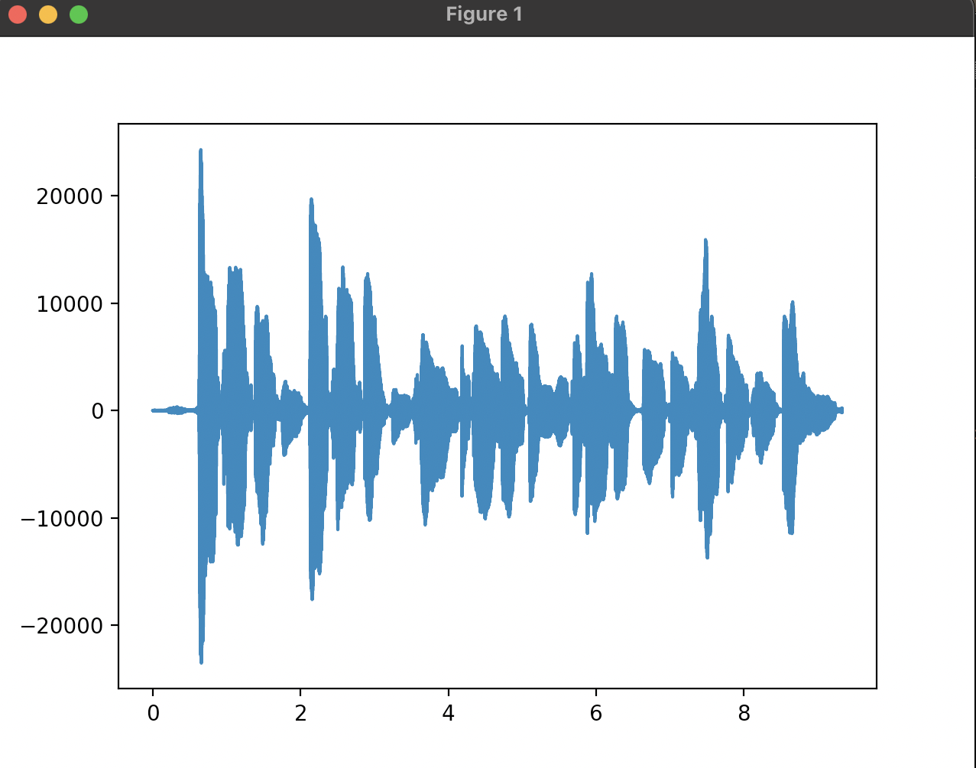

12K

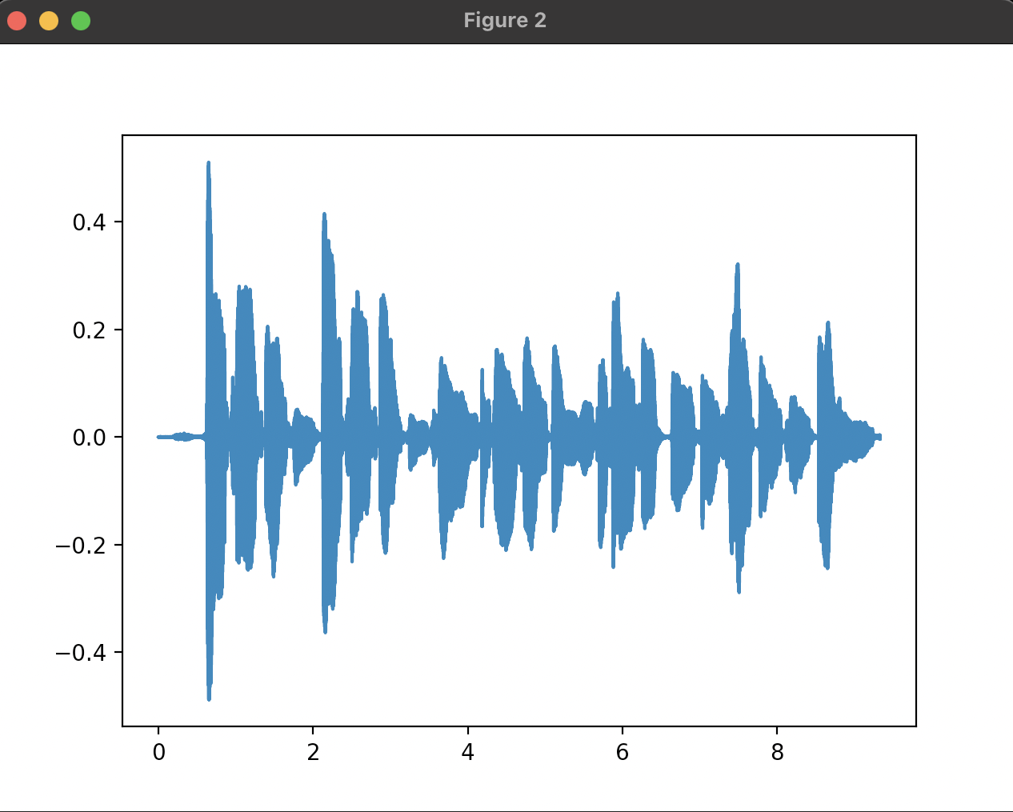

16K

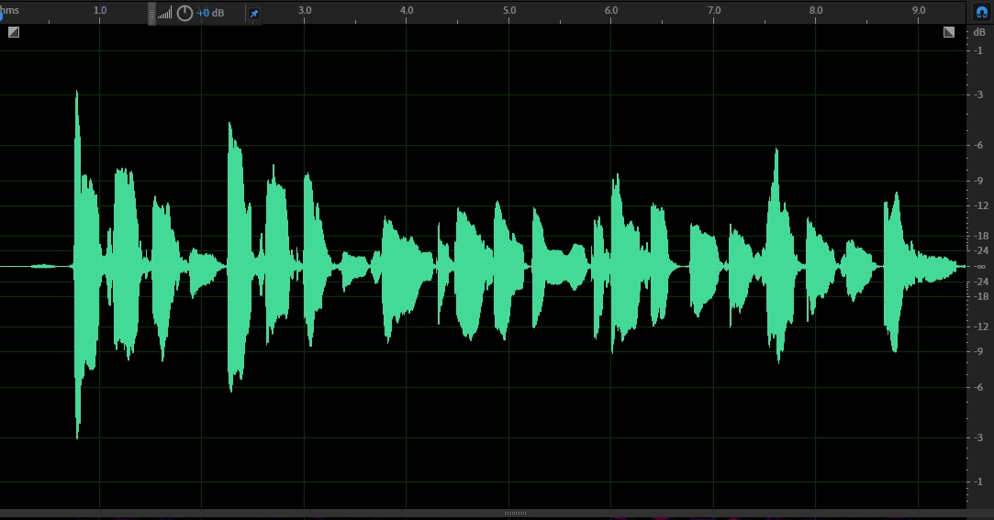

12K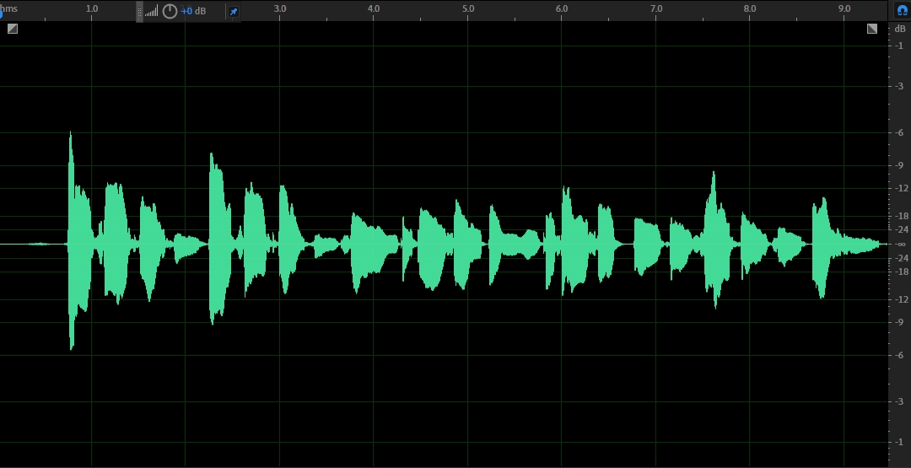

結果：

聲音音質變差